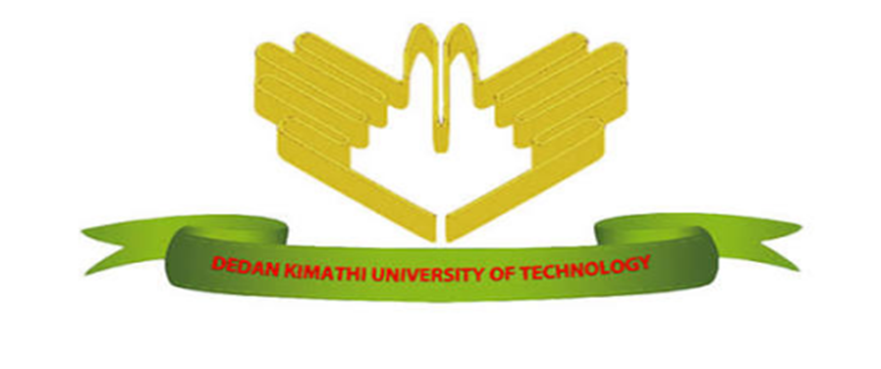

DEDAN KIMATHI UNIVERSITY OF TECHNOLOGY

DEPARTMENT OF COMPUTER SCIENCE AND IT

**ONLINE MOVIE TICKET BOOKING**

BY

MARTIN KANYI MAHUGU

C132-01-0294/2022

SUPERVISOR

IRAD MWENDO

Project documentation submitted to the Department of Information Technology in the school of Computer Science and Information Technology in partial fulfilment of the requirements for the award of Diploma in Information Technology at Dedan Kimathi University of Technology.

April, 2023

# DECLARATION

This proposal is my original work carried out during the course of my studies and has not been presented to other universities for awards.

Name: ………………………………….

Signature: …………………………. Date: …………………………

This proposal has been submitted for examination with my approval as university as university supervisor.

Name: ………………………………….

Signature: …………………………. Date: …………………………

# ABSTRACT

Watching movies with family and friends in theatres is one of the best mediums of entertainment after having a hectic schedule. The purpose of this system is to provide an easy and simple way for movie viewers to perform ticket booking in movie theaters. The system aims to eradicate the requirement of standing in line for a while in order to purchase a movie ticket by introducing an online platform whose features improve on efficiency, energy used and amount of time taken. Due to increase in technology and digitalization the online movie ticket booking system has brought comfort to movie viewers by allowing them to sit at home browse for movies which have been released and then book tickets according to their schedule.

Contents

1 DECLARATION i

2 ABSTRACT ii

4 CHAPTER ONE 1

5 INTRODUCTION 1

5.1.1 Background information 1

5.2 PROBLEM STATEMENT 1

5.3 OBJECTIVES 2

5.3.1 Main Objective 2

5.3.2 Specific objectives 2

5.4 RESEARCH QUESTIONS 2

5.5 JUSTIFICATION 2

5.6 SCOPE 2

5.7 LIMITATIONS 3

6 3

7 4

8 4

9 4

10 CHAPTER TWO 4

11 LITERATURE REVIEW 4

11.1 Background information 4

11.2 Case studies 4

11.2.1 Case study 1: Fandango 4

11.2.2 Case study 2: Ticket please.com 4

11.3 Online booking/Reservation 4

11.4 RESEARCH GAP 5

11.4.1 Content range 5

12 6

13 6

14 6

15 CHAPTER THREE: METHODOLOGY 6

16 INTRODUCTION 6

16.1 Fact finding techniques 6

16.1.1 Existing systems 6

16.1.2 In-Depth interviews 6

16.2 RESOURCES 6

16.2.1 HARDWARE REQUIREMENTS 6

16.2.2 SOFTWARE REQUIREMENTS 6

17 8

18 8

19 CHAPTER FOUR: SYSTEM ANALYSIS AND DESIGN 8

20 INTRODUCTION 8

20.1 REQUIREMENT ANALYSIS 8

20.1.1 Functional requirements 8

20.1.2 Non- functional requirements 9

20.2 SYSTEM DESIGN 9

20.2.1 Use case diagram 9

20.2.2 9

20.2.3 Deployment diagram 10

20.2.4 Data flow diagram 11

20.2.5 Level 0 diagram 11

20.2.6 Level 1 diagram 12

21 CHAPTER FIVE: TESTING AND IMPLEMENTATION 13

22 INTRODUCTION 13

22.1 FUNCTIONAL TESTING 13

22.1.1 UNIT TESTING 13

22.1.2 INTERGRATION TESTING 15

22.1.3 SYSTEM TESTING 15

22.1.4 SECURITY TESTING 15

22.1.5 USER TESTING 15

22.2 IMPLEMENTATION 15

23 20

24 CHAPTER SEVEN: CONCLUSION AND RECOMMENDATIONS 20

24.1 CONCLUSIONS 20

24.2 RECCOMENDATIONS 20

25 CHAPTER 8 : REFERENCES 21

List of figures

Figure 1use case diagram 10

Figure 2Deployment diagram 11

Figure 3 Level 0 DFD 12

Figure 4 Level 1 DFD 12

Figure 5 Login Test 14

Figure 6 Use Signup Test 14

Figure 7 Homepage 16

Figure 8 Movies Page 16

Figure 9 movies page 17

Figure 10 Movies page 17

Figure 11 Theaters page 18

Figure 12 Showtimes page 18

Figure 13 Showtimes page 19

Figure 14 Seat Booking Page 19

# CHAPTER ONE

# INTRODUCTION

### Background information

Online movie ticket booking system is a web-based system that is basically made for booking a ticket anywhere and anytime and get information about the movies online. It is an automated system that provides an alternate and convenient way for a customer to book a movie ticket instead of waiting inline. The customer will select any movies he/she wants and they will be able to view some information related to the film e.g., description, tittle, release date and age rating. The system will also provide the show timing and available seats in specific theaters. In this system, the staff of the cinema hall won’t have to do anything as all processes will be done by the users themselves on the platform this will help the owner reduce the number of staff.

Today, it is believed that application of computer technology in any activity would go a long way in making the activity much easier. The implementation of the online movie ticket booking will bring about benefits and advantages that will out weight the manual methods of ticket reservation.

With the development of technology, digitalization and increasing social networking, information sharing on the internet has become very popular and easy. This has brought about discussion of online systems and improvements in already existing systems like the movie ticket booking.

Digitalization has given easy accessibility of resources required to implement an online system hence ruling out the need of wasting time in queues at cinemas. Online payment through E-banking has also helped in shortening the lengthy process. The system will also allow the viewer to select any timing slot and they have the authority to choose any seat according to their convenience.

## PROBLEM STATEMENT

A cinema hall’s way of ticket booking in the previous years has made it necessary for a customer to go to a specific theatre where the movie is playing and stand in queue to buy the ticket. This can be considered time consuming and straining. The owner of a cinema usually has to sit down and manage every aspect of ticket booking, seat management, ticket cancellation and payment services. This task may sometimes prove to be challenging and any mistake can be made without the owner’s knowledge. Movie viewers also require to know which movies being shown in the theatre and the release dates of other shows allowing them to book in advance.

## OBJECTIVES

### Main Objective

The main objective of this project is to develop an online movie ticket booking system.

### Specific objectives

The system should be able to: -

1. Register a new user into the system.
2. Add and view the list of movies in the system.
3. Book a ticket for a specific movie entry.
4. Select any seat that isn’t booked.

## RESEARCH QUESTIONS

1. Will the system be able to register users?
2. Will the system handle addition of new movies and display the movie list?
3. Will the system help to book movie tickets?
4. Will the user be able to make to book seats?

## JUSTIFICATION

The online platform will greatly reduce the time taken to book tickets to movies and shows by standing in line. Now a customer only needs a smart phone and internet connection to access the online booking service. The project will also ensure the cinema management has an efficient method of storing client data securely. This will make customers experience smooth and pleasant.

## SCOPE

The proposed system will aid in ticket and show booking and all necessary transactions involved.

The scope of the system will be limited to the following:

1. Owner profile

* The owner has full access to the system
* The owner has the authority to change the list of movies
* He can also monitor transactions carried out during a period of time.

1. Viewer profile

* The viewer can check on information related to a movie.
* The viewer can check availability of tickets and seats.
* The viewer can perform the booking process online.

## LIMITATIONS

* There is no online payment process yet only booking for seats.
* A viewer must have access to a smart gadget and strong secure network in order to perform the online booking.
* Some users might be illiterate when it comes to working with web-based applications.

# 

# 

# CHAPTER TWO

# LITERATURE REVIEW

## Background information

This chapter presents the reviewed literature related to the topic of study. This section covers the different ideas on which system designers and builders depended on to construct and improve the means of online movie ticket booking.

## Case studies

### Case study 1: Fandango

Fandango is an example of a famous movie ticket booking website. It’s a USA based company which books movie ticket. It provides information on the latest movies, theatre listings, top box office results, entertainment news and more. Upcoming movie lists are well synchronized on this web site and there is even previous booking systems available for the upcoming movie with a coupon code.

### Case study 2: Ticket please.com

Ticket please.com is another example of a famous online movie ticket booking system that performs booking for college concerts, plays and sport events. It offers the user a facility of buying tickets online along with a lot of offers &features that would keep viewers entertained. Once a user is signed in, they get full access to the facilities available in the website. The website provides facilities like trailers and movie review.

The main common modules of the systems are ticket booking, movie, hall, payment and add/update/delete movie booking details.

## Online booking/Reservation

Based on Pedone (2001), wide spread use of the internet has led to the emergence of variety of electronic services. Electronic ticket or E-ticket is an example of such a class of e-service-tickets give evidence to their holders to have permission enter a place of entertainment, use a means of transportation, or have access to some Internet services. E-tickets give evidence to their holders to have permission to enter a place of entertainment, use means of transportation or have access to some internet services. Users can get the tickets by purchasing them from a web server or simply receiving from a vendor or from another user who previously acquired them. E-tickets can be stored in a desktop computer or personal digital assistants for future use. For some cases, like e-tickets non transferable example e-ticket airline, it has to be validated to prevent duplication and ensure authenticity and integrity. The validation process is called e-ticket problem. Here results in the server either accept or reject the e-ticket and intended to prevent duplication which avoids multiple use of an e-ticket by the same or different users, ensuring authenticity and integrity that e-tickets are only accepted if they have been issued by an authorized source and have not been tampered with. In addition to privacy, it is desirable that e-tickets should not contain any information associated with their holders. The validation process is called e-ticket problem here, results in the server either accepts or rejects the e-ticket, and intended to prevent duplication which avoids multiple use of an e-ticket by the same or different users; ensuring authenticity and integrity that e-tickets are only accepted.

## RESEARCH GAP

### Content range

The online movie booking platforms need to find a way to increase the variety of content enjoyed by different users. Some shows aren’t available for booking and this limits and reduces the number of viewers.

Online payment systems for the ticket should be developed to smoothen the booking process.

# 

# CHAPTER THREE: METHODOLOGY

# INTRODUCTION

This chapter contains all research methodology that was used to collect data about the online movie ticket booking platform.

## Fact finding techniques

### Existing systems

Research was conducted based on various available movie booking web sites and applications. The various systems were also analyzed to get an idea of what are the features, which have already been implemented and what are the features that can be added to the system to improve efficiency and ease.

### In-Depth interviews

Movie viewers were questioned about their experience in both offline and online ticket booking. Their feedback was used to analyze what features and modules needed to be added to an online ticket booking system and which they preferred method they found the best. The user’s behavior when performing offline was not positive and they hated it as queues to epic films could be quite long. They preferred online booking as it was faster and could easily be done from the comfort of your home through an internet connection.

This brought about a realization that many users didn’t like queueing for hours to purchase a ticket as it would be disruptive to their daily schedule. The users also wanted more information about the movies like description the movies.

## RESOURCES

### HARDWARE REQUIREMENTS

* Laptop or pc

### SOFTWARE REQUIREMENTS

* Operating system: windows 10
* HTML, CSS and JavaScript. (Front end)
* IDE: sublime text
* MySQL and PHP (Back end)
* Xampp software

# CHAPTER FOUR: SYSTEM ANALYSIS AND DESIGN

# INTRODUCTION

System analysis – It is a process of collecting and interpreting facts, identifying the problems, and decomposition of a system into its components. System analysis is conducted for the purpose of studying a system or its parts in order to identify its objectives. It is a problem-solving technique that improves the system and ensures that all components of the system work efficiently to accomplish their purpose.

System design: It is a process of planning a new business system or replacing an existing system by defining its components or modules to satisfy the specific requirements. Before planning, you need to understand the old system thoroughly and determine how computers can best be used in order to operate efficiently.

## REQUIREMENT ANALYSIS

A requirement is a statement of what the system must do or a statement of characteristics the system must have. Requirements determination involves studying the existing system and gathering details to find out what are the requirements, how it works, and where improvements should be made.

Requirement analysis is also referred to as requirement engineering, it is a process of determining the user specifications from the proposed system.

### Functional requirements

Statements of services the system should provide, how the system should react to particular inputs and how the system should behave in particular situations. This defines the functioning of the systems and how some of the components are integrated in the system so as to work efficiently. Some of the functionalities are:

1. A registered user should be able to login and a new user should be able to register and get access into the system.
2. The user views a list of movies that are available for viewing in the theaters.
3. The user should be able to select showtimes and select seats for booking in the movie theaters.
4. The user can logout of the system and login at a later time.

### Non- functional requirements

1. Easy to use – The system is simple and easy to use for all users.
2. Understandable – The user is able to understand the the functionalities of the system as it is very user friendly.
3. Confidentiality – Each user is required to login so as to access the movies for booking.
4. Reliability – The system can be accessed at any time of the day by any user.

## SYSTEM DESIGN

After conducting all the research, a proposed system was set to be developed with an owner profile, where the owner can create new entries to databases, view the available tickets for movies and look into the day-to-day transactions of the system and a viewer profile, where a viewer can check for tickets and book.

### Use case diagram

### 

A Use Case is a description of the system’s behaviour from a user’s viewpoint.

This diagram is a valuable aid during analysis, developing Use Cases helps us to understand requirements.

A use case diagram is simple to understand. This enables both developers (analysts, designers, coders, tests) and the customer to work with the diagram.

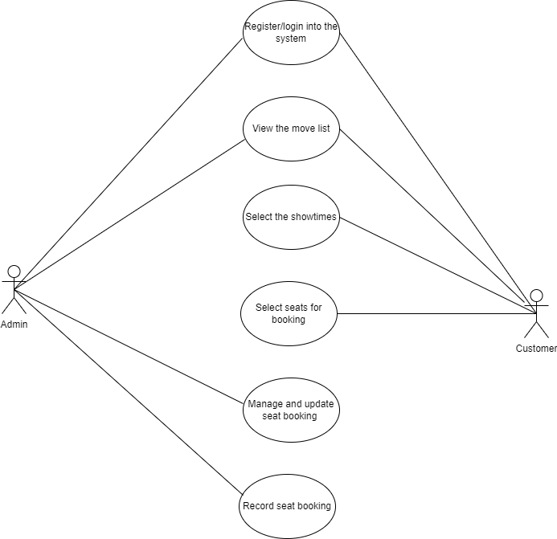

Figure use case diagram

### Deployment diagram

Deployment diagrams are used to show the configuration of run-time processing elements and the software components and processes that are located on them. Deployment diagrams are made up of nodes and communication associations. Nodes are typically used to show computers and the communication associations show the network and protocols that are used to communicate between nodes. Nodes can be used to show other processing resources such as people or mechanical resources.

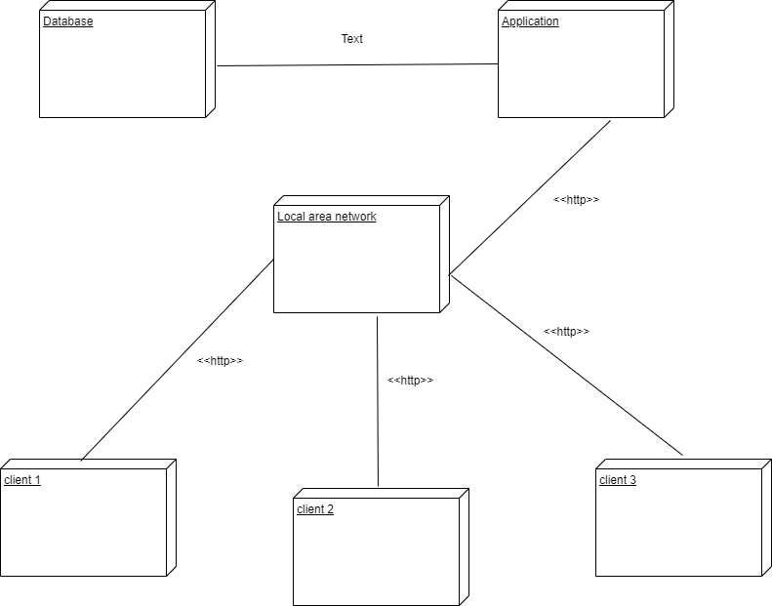

Figure Deployment diagram

### Data flow diagram

A data flow diagram describes the overall flow of data on the system. It is used to document the transformation of data (input-output) for system development. A data flow diagram is also used to visualize the systems data management at various levels.

### Level 0 diagram

It demonstrates the project concept using the single process visualization. It shows the entities that interact with a system and defines the border between the system and its environment.

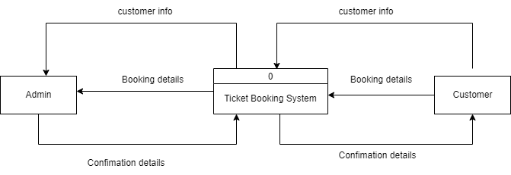

Figure Level 0 DFD

### Level 1 diagram

Its function is to deepen the concept derive from the context diagram. It shows the broader details of a level 0 DFD to clarify the paths of data and its transformation from input to output.

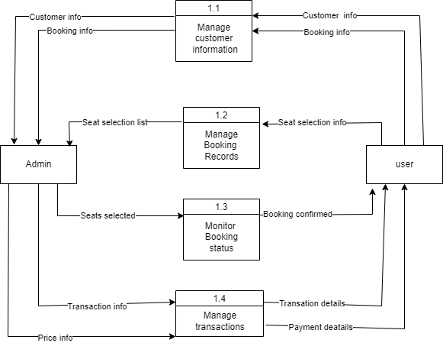

Figure Level 1 DFD

# CHAPTER FIVE: TESTING AND IMPLEMENTATION

# INTRODUCTION

Testing is intended to show that a program does what it is intended to do and to discover program defects before it is put into use.

Software testing is concerned with exercising and observing product behaviour which means system is executed with test data and its operational behaviour is observed.

The online movie booking system is a platform that is going to be accessed by many users at different times. The platform management can be a daunting task especially when the system has not been tested properly to prove all its functional and non-functional requirements are working. The goal is to create a system that is easy to navigate and use and still has the security and features expected from quality online ticket booking system.

## FUNCTIONAL TESTING

### UNIT TESTING

This is the type of testing where individual program units or object classes are tested. It is a defect testing process. Unit testing includes testing of smallest piece of software to verify its behaviour. It ensures that the code should satisfy the requirements. This helps reduce future maintenance cost.

#### User Login Test

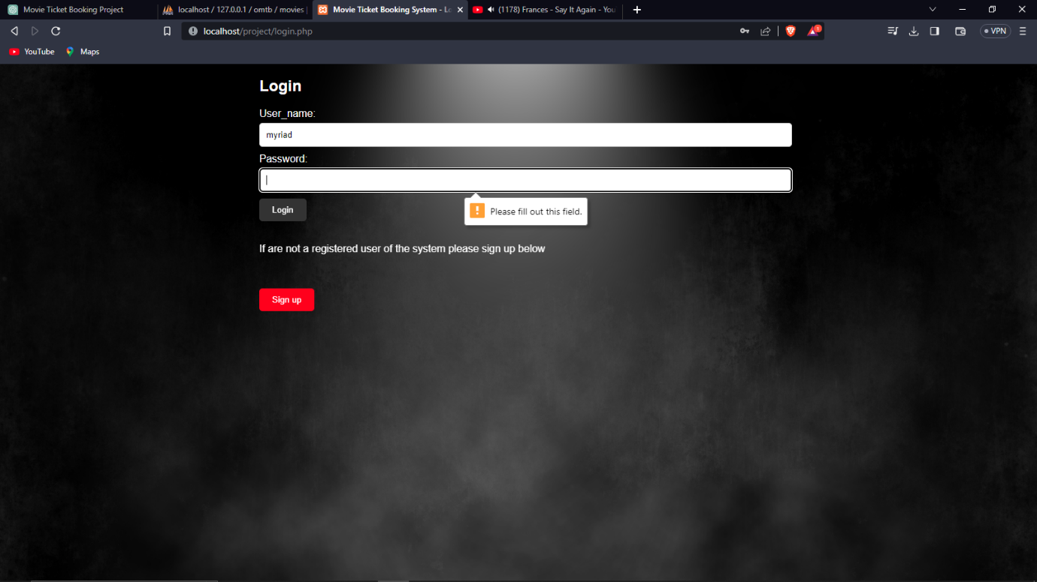

Figure Login Test

The login page requires a user to enter a password in order to login into the system. The system displays and error message that requires to fill out the password field.

#### New User Sign up test

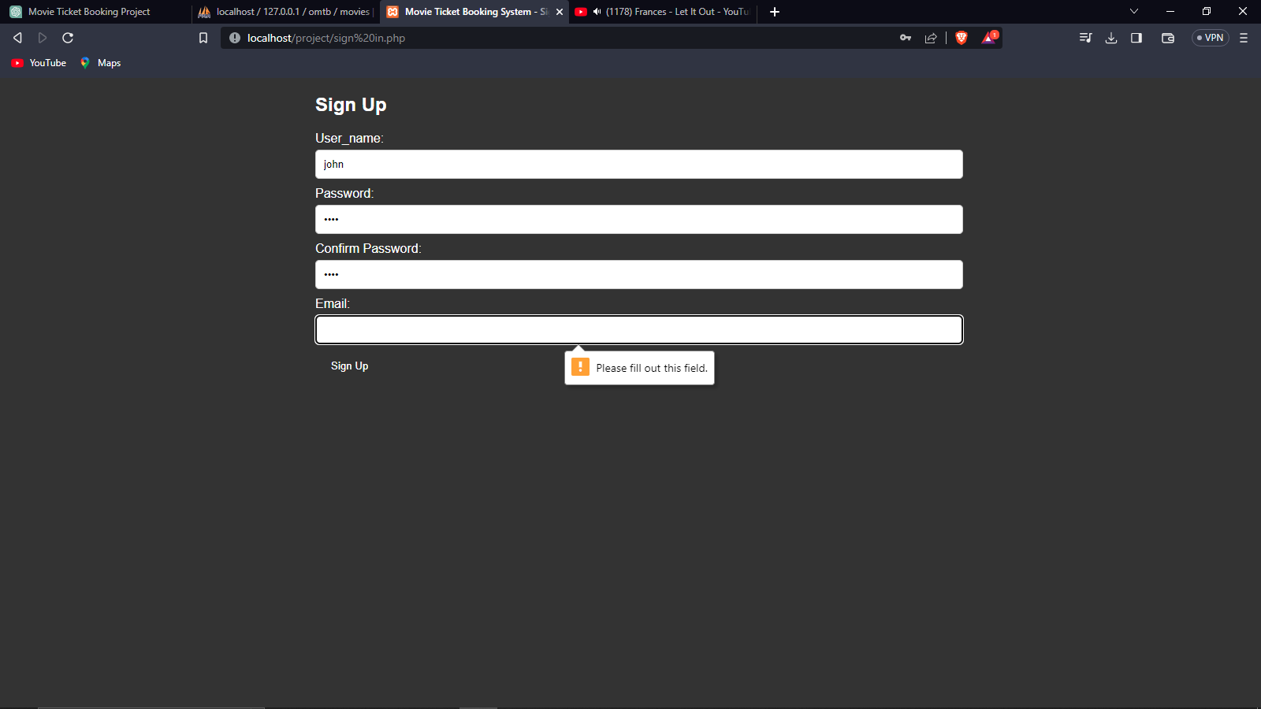

Figure Use Signup Test

The sign up requires all user information so that it can create an account and password for user login. This means none of the fields on the form can be left empty they have to be filled in for entry into the database.

### INTERGRATION TESTING

Integration testing is done to ensure that individually tested components can work together to perform the intended task. Integration testing is important because modules work individually but they may not work together when they are integrated. It is used to discover the various issues which occur in interfaces between modules.

### SYSTEM TESTING

System testing involves integrating components to create a version of the system and then testing the integrated system. The focus in system testing is testing the interactions between components. System testing checks that components are compatible, interact correctly and transfer the right data at the right time across their interfaces. System testing is done after integration testing. When all modules are in integrated state and working as a single application at that time system testing is done.

### SECURITY TESTING

Security testing is done to determine how secure is the system or website is secure from internal and external threats. This test verifies that no unauthorized access to confidential data was allowed. This testing includes how much software is secure from the malicious program, viruses and how secure and strong the authorization and authentication processes are.

### USER TESTING

User testing are testing scenarios that determine whether the system can be easily understood and navigated. User testing is an essential test because influences from the user’s working environment have a major effect on the reliability, performance, usability and robustness of a system. These cannot be replicated in a testing environment.

## IMPLEMENTATION

It is the process of adopting and integrating a system into a business workflow. This includes activities such as user notification, user training, installation of hardware, installation of software on to production computers and integration of the system into daily work processes.

### Homepage

This is the first page a user views after they have logged into the system. It displays some information of what the system does and welcomes the user.

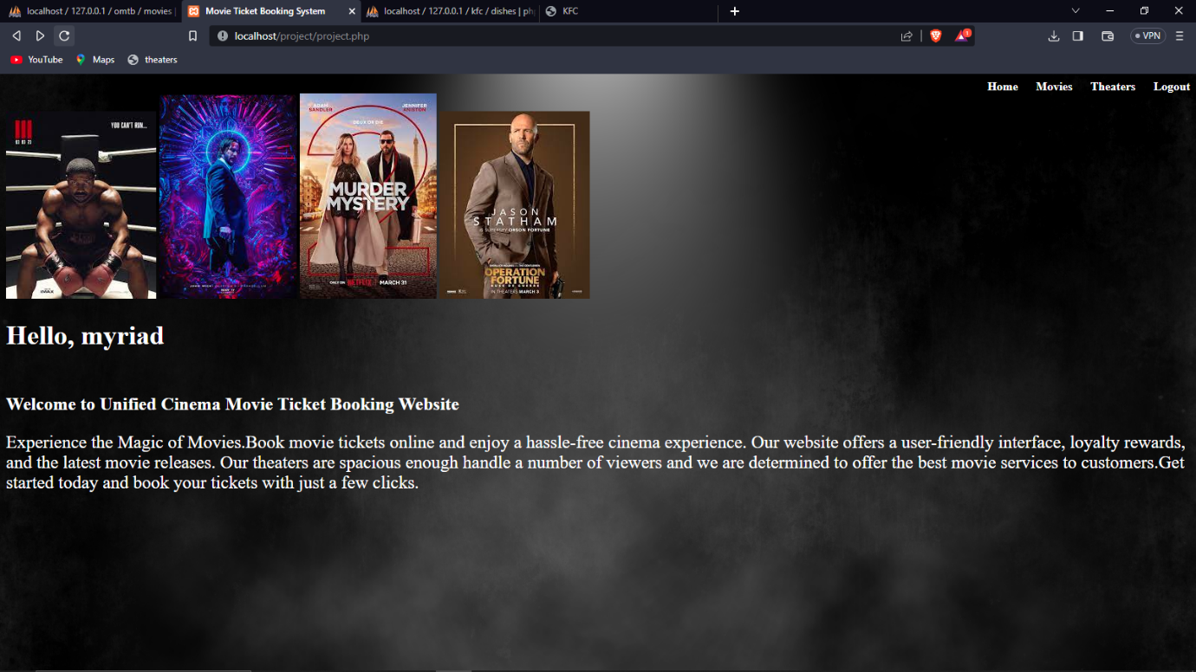

Figure Homepage

### Movie page

The movie page displays a list of movies in a container that has the movie tittle, release date, runtime, rating and description.

The page also contains a select showtimes button that redirects to the showtimes page for a user to select the specific time they want to view the movie selected.

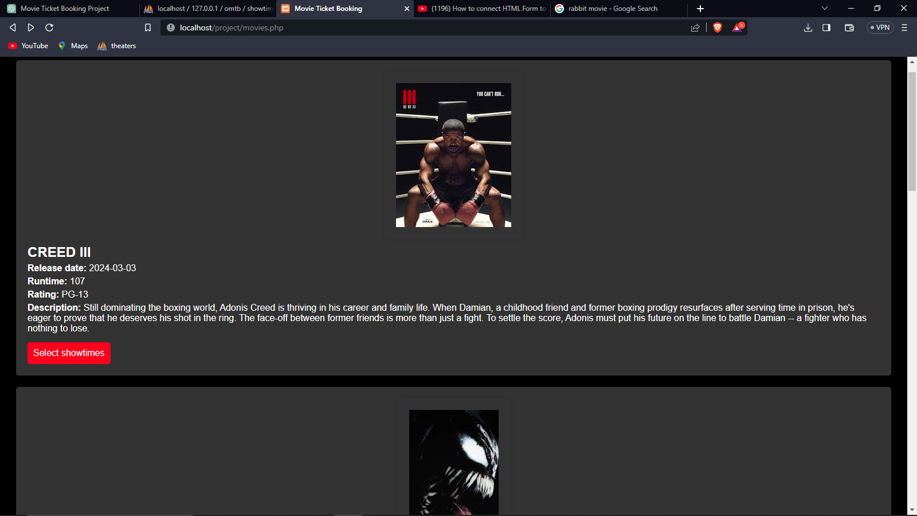

Figure Movies Page

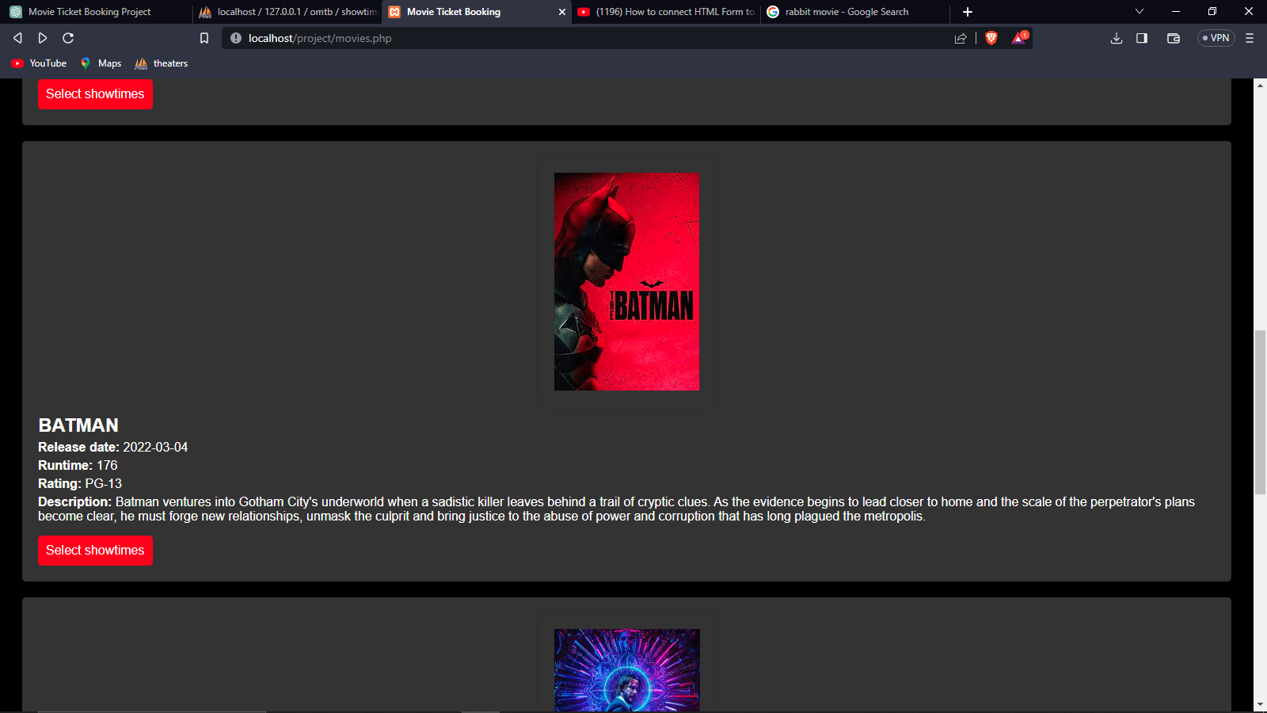

Figure movies page

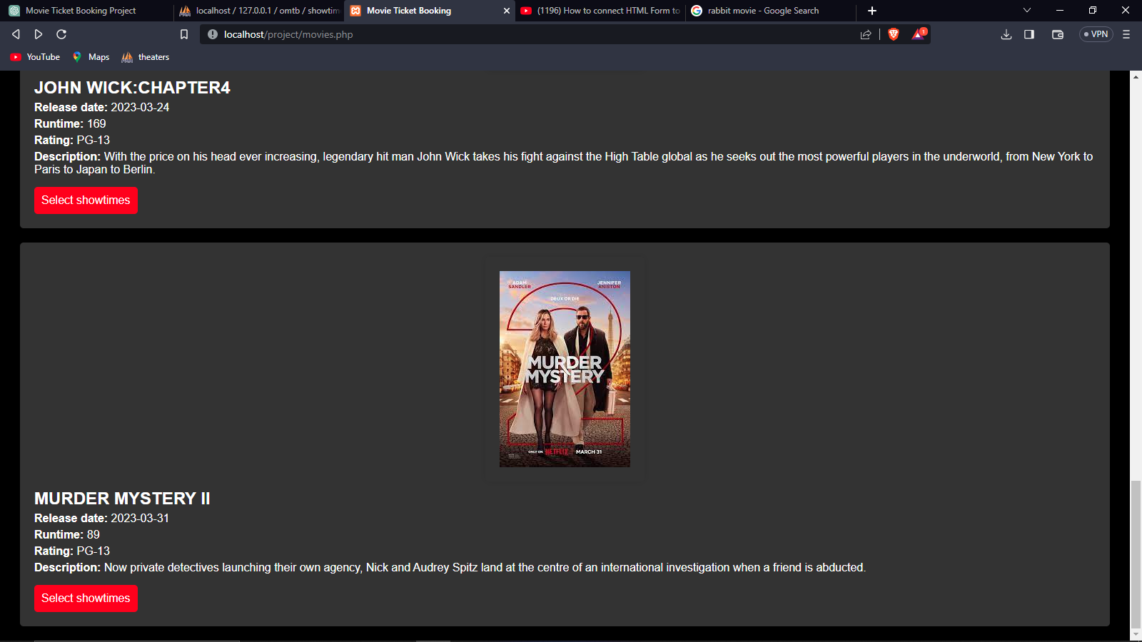

Figure Movies page

### Theaters page

This is a page that displays the movie theaters in the cinema and the capacity they hold.

The page also has a watch movie button that allows the user to select a movie.

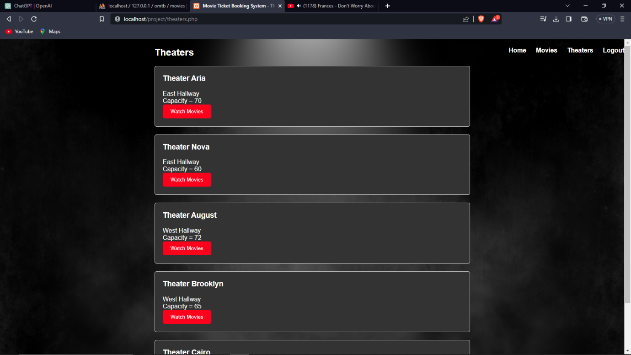

Figure Theaters page

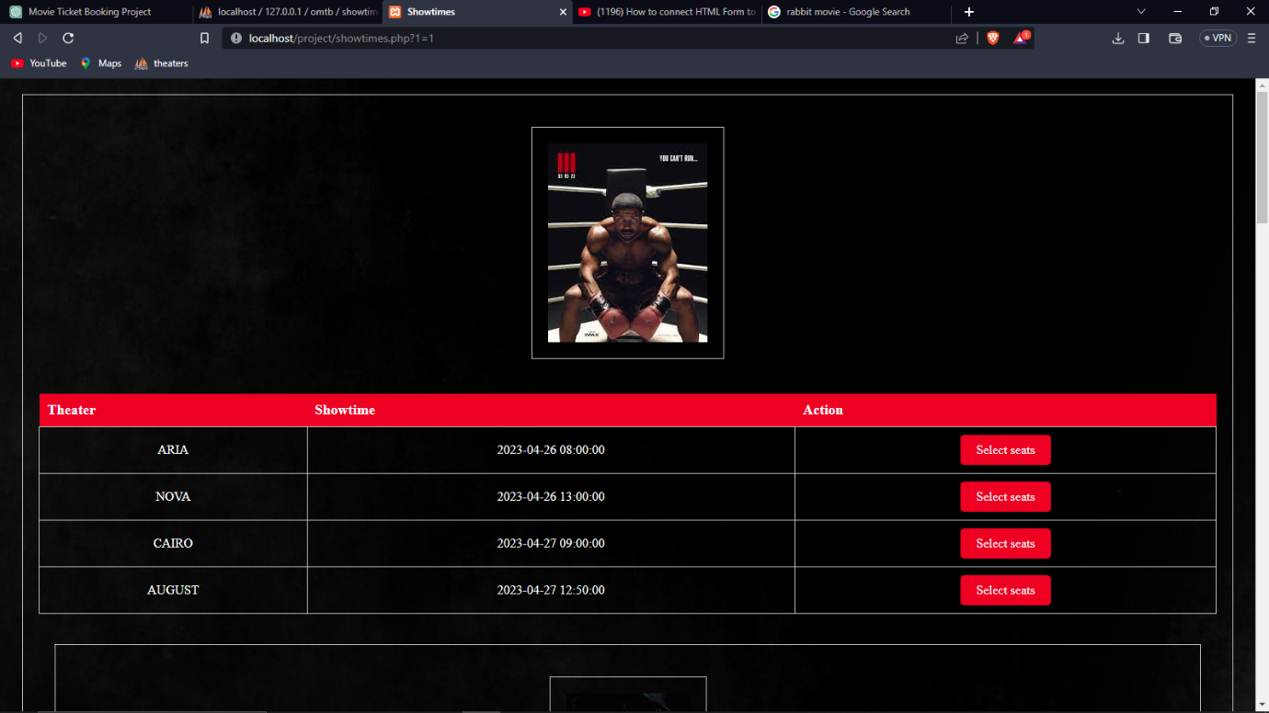

Figure Showtimes page

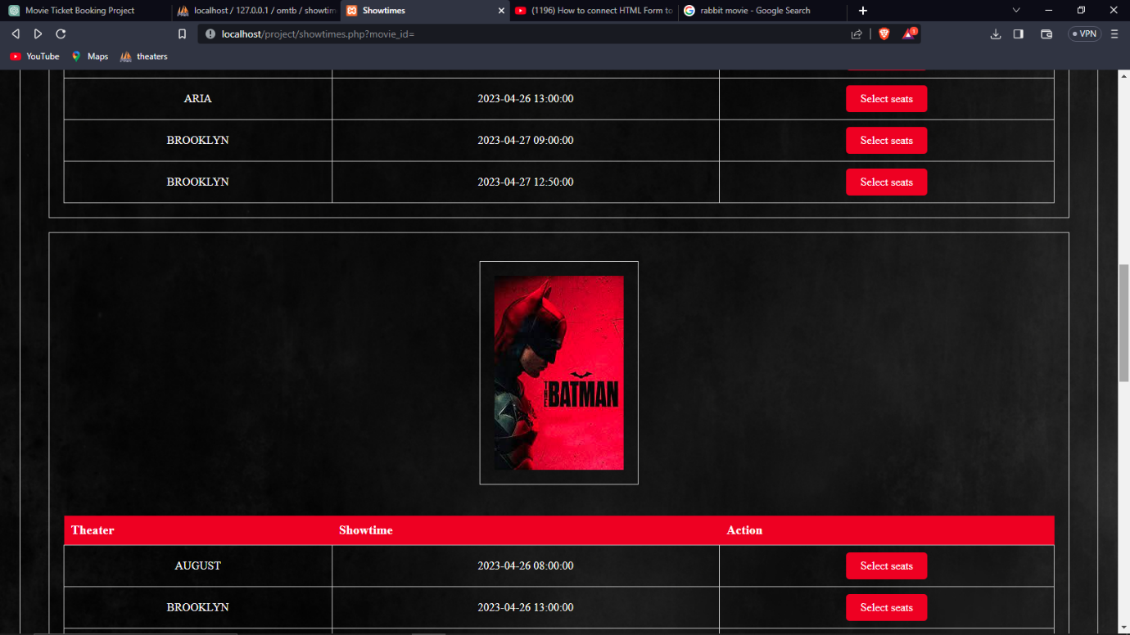

Figure Showtimes page

### Seat Booking page

This page has a list of movie selections for booking. The page also displays a screen and a number of seats. The seats are marked either as available, selected or sold.

The information of the selected seats and the booking form is submitted to the booking table in my database for saving.

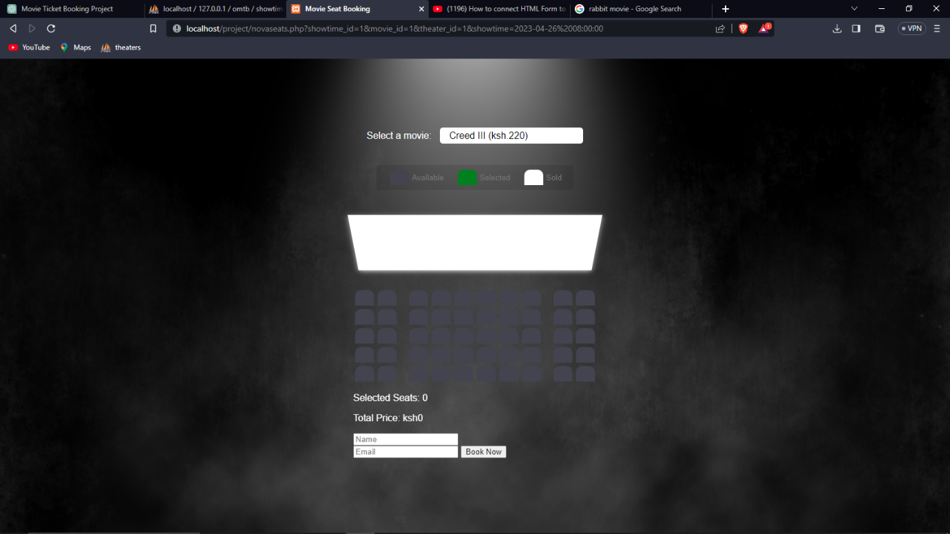

Figure Seat Booking Page

# 

# CHAPTER SEVEN: CONCLUSION AND RECOMMENDATIONS

## CONCLUSIONS

ONLINE MOVIE TICKET BOOKING is the ticket booking service that allows the customers to book the movie tickets on the computerized networks such as internet through secure website with a particular movie booking system, which has resulted from the blossoming Internet technology, obviously has many benefits for the user by getting the entertainment without wasting the time by standing in queue for hours and hours

## RECOMMENDATIONS

After creating the system the suggested recommendations for improvement are :

1. The next development group should create better databases to store all client info securely and all user profiles should be personalized.
2. The next development group should work on creating an online payment system to purchase the tickets booked.
3. The next system should generate a report for the owner about all bookings done on a specific day to help them keep track of all activities.

# CHAPTER 8 : REFERENCES

* Armelius, H., Guibourg, G., Johansson, S., & Schmalholz, J. (2020). E-krona design models: pros, cons and trade-offs. *Sveriges Riksbank Economic Review*, *2*, 80-96.
* De Luna, I. R., Liébana-Cabanillas, F., Sánchez-Fernández, J., & Muñoz-Leiva, F. (2019). Mobile payment is not all the same: The adoption of mobile payment systems depending on the technology applied. Technological Forecasting and Social Change, 146, 931-944.
* Fernado, P 2000, a two-Phase Highly-Available Protocol for Online Validation of E-Tickets: Software Technology Laboratory.
* Rouibah, K., Lowry, P. B., & Hwang, Y. (2016). The effects of perceived enjoyment and perceived risks on trust formation and intentions to use online payment systems: new perspectives from an Arab country. Electronic Commerce Research and Applications, 19, 33-43.